**Requirement Gathering and Analysis Phase**

**Data Flow Diagram & User Stories**

|  |  |
| --- | --- |
| Date | 29 June 2024 |
| Team ID | SWTID1720004076 |
| Project Name | Wise Wallet: Your Budgeting Partner |
| Maximum Marks |  |

**Data Flow Diagrams:**

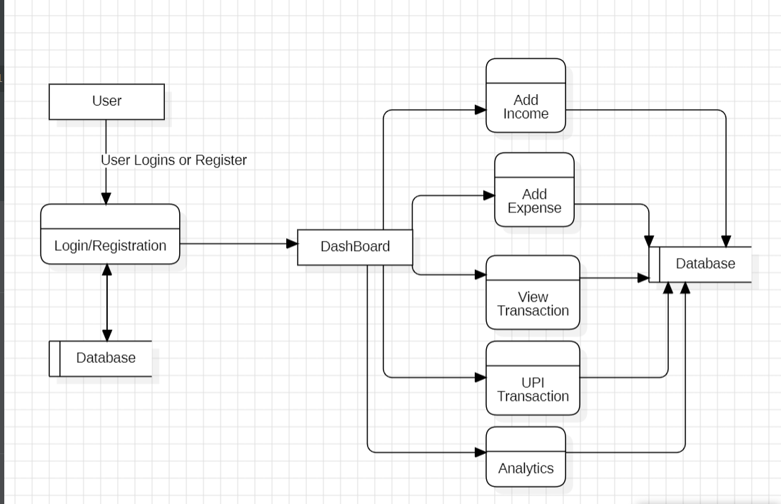

**User Stories**

Use the below template to list all the user stories for the product.

| **Sprint** | **Functional Requirement (Epic)** | **User Story Number** | **User Story / Task** | **Story Points** | **Priority** | **Team Members** |
| --- | --- | --- | --- | --- | --- | --- |
| Sprint-1 | Registration | USN-1 | As a user, I can register for the application by entering my email, password, and confirming my password. | 4 | High | Sathvik |
| Sprint-1 |  | USN-2 | As a user, I will receive a confirmation email once I have registered for the application. | 2 | High | Sunanda |
| Sprint-2 |  | USN-3 | As a user, I can register for the application through Facebook | 4 | Low | Arun |
| Sprint-1 |  | USN-4 | As a user, I can register for the application through Gmail | 4 | Medium | Atareya |
| Sprint-1 | Login | USN-5 | As a user, I can log into the application by entering email & password | 2 | High | Sathvik |
| Sprint-1 |  | USN-6 | As a user, I can reset my password if I forget it. | 4 | High | Arun |
| Sprint-2 | Dashboard | USN-7 | As a user, I can view a dashboard that shows a summary of my financial status. | 6 | High | Sunanda |
| Sprint-2 | Income Management | USN-8 | As a user, I can add my income details including source and amount. | 4 | High | Attreya |
| Sprint-2 | Expense Management | USN-9 | As a user, I can add my expense details including category and amount. | 6 | High | Arun |
| Sprint-2 |  | USN-10 | As a user, I can view a summary of my income and expenses on the dashboard. | 4 | High | Sunanda |
| Sprint-3 | Transaction History | USN-11 | As a user, I can view the history of all my transactions. | 6 | High | Sathvik |
| Sprint-3 |  | USN-12 | As a user, I can filter my transaction history by date range. | 4 | Medium | Attareya |
| Sprint-3 |  | USN-13 | As a user, I can search for specific transactions in my history. | 6 | Medium | Sunanda |
| Sprint -3 | Report generation | USN-14 | As a user, I can generate report of the transactions made in a month or a year. | 4 | Medium | Attareya |
| Sprint-4 | UPI Transactions | USN-15 | As a user, I can add UPI transactions done through different apps. | 8 | High | Arun |
| Sprint-4 |  | USN-16 | As a user, I can categorize UPI transactions into income or expenses. | 6 | Medium | Sathvik |
| Sprint-4 |  | USN-17 | As a user, I can view UPI transactions separately in the transaction history. | 6 | Medium | Attareya |
| Sprint-5 | Analytics | USN-18 | Based on data as a user I can see the analytics pattern of my spending and income. | 8 | High | Sathvik |
| Sprint-5 | Account settings | USN-19 | As a user, I can update my account settings including email and password. | 6 | Medium | Sunanda |
| Sprint-5 |  | USN-20 | As a user, I can set preferences for notifications and privacy. | 6 | Medium | Sathvik |